SAMPLE COLLECTION, STORAGE, AND CHARACTERIZATION
The blood or semen that [the perpetrator of a crime] deposits or collects—all these and more bear mute witness against him. This is evidence that does not forget.… Physical evidence cannot be wrong; it cannot perjure itself; it cannot be wholly absent.… Only human failure to find, study and understand it can diminish its value.
—Paul Kirk, Crime Investigation, 1953

Before a DNA test can be performed on a sample, it must be collected and the DNA isolated and put in the proper format for further characterization. This lecture covers the topics of sample collection and preservation. These steps are vital to obtaining a successful result regardless of the DNA typing procedure used. If the samples are not handled properly in the initial stages of an investigation, then no amount of hard work in the ﬁnal analytical or data interpretation steps can compensate.

SAMPLE COLLECTION
DNA sample sources
DNA is present in every nucleated cell and is therefore present in biological materials left at crime scenes. DNA has been successfully isolated and analyzed from a variety of biological materials. Introduction of the polymerase chain reaction (PCR) has extended the range of possible DNA samples that can be successfully analyzed because PCR enables many copies to be made of the DNA markers to be examined. While the most common materials tested in forensic laboratories are typically bloodstains and semen stains, there is a listing from one laboratory of over 100 unusual casework exhibit materials that yielded successful DNA proﬁles.

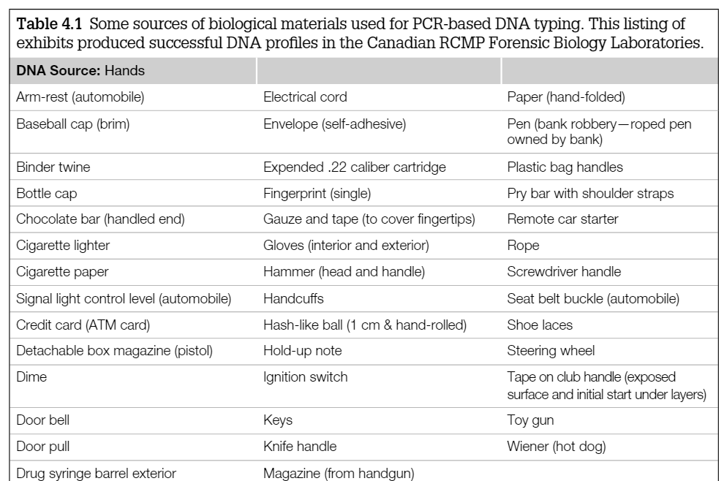
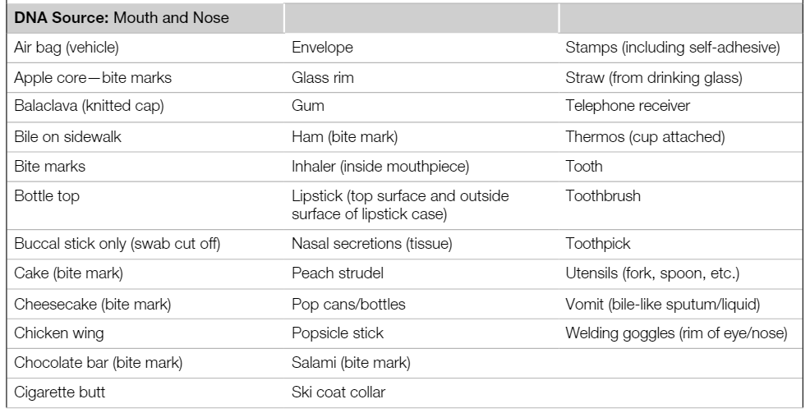

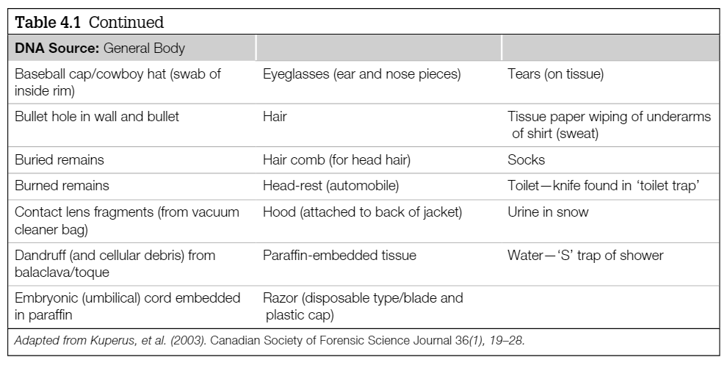

DNA molecules are amazingly durable and in many cases can yield DNA typing results even when subjected to extreme conditions such as irradiation. For example, the U.S. Postal Service began using electron-beam irradiation of mail (for some ZIP postal codes in Washington, DC) as a protective measure against terrorism with biological agents following the anthrax attacks on the Senate Office Building in October 2001. The irradiation is performed at levels demonstrated to cleave microbial DNA and prevent passage of harmful materials such as anthrax. However , recovering human DNA and developing a DNA profi le from licked stamps and envelope fl aps can sometimes be important in tracing the origin of threatening letters. Two studies have been published examining the effects of electron-beam irradiation on buccal-cell DNA. Both studies concluded that while electron-beam irradiation reduces the yields and quality of DNA extracted from buccal-cell collections, the short tandem repeat DNA typing systems used in human identity testing could still be successfully amplified.

Biological evidence at crime scenes
The different types of biological evidence collected at a crime scene (e.g., Table 4.1) can be used to associate or to exclude an individual from involvement with a crime. In particular, the direct transfer of DNA from one individual to another individual or to an object can be used to link a suspect to a crime scene. As noted by Henry Lee of the Connecticut State Forensic Laboratory, this direct transfer could involve:
1. the suspect’s DNA deposited on the victim’s body or clothing,
2. the suspect’s DNA deposited on an object,
3. the suspect’s DNA deposited at a location,
4. the victim’s DNA deposited on a suspect’s body or clothing,
5. the victim’s DNA deposited on an object,
6. the victim’s DNA deposited at a location,
7. the witness’s DNA deposited on the victim or suspect, or
8. the witness’s DNA deposited on an object or at a location.
DNA evidence collection from a crime scene must be performed carefully and a chain of custody established in order to produce DNA proﬁles that are meaningful and legally accepted in court. DNA testing techniques have become so sensitive that biological evidence too small to be easily seen with the naked eye can be used to link suspects to crime scenes. The evidence must be carefully collected, preserved, stored, and transported prior to any analysis conducted in a forensic DNA laboratory. The National Institute of Justice has produced a brochure entitled ‘What Every Law Enforcement Ofﬁcer Should Know About DNA Evidence’ (now available as online training as well; see http://www.dna.gov) that contains helpful hints for law enforcement personnel who are the ﬁrst to arrive at a crime scene.

Evidence collection and preservation
The importance of proper DNA evidence collection cannot be overemphasized. If the DNA sample is contaminated from the start, obtaining clear information becomes a challenge at best and an important investigation can be compromised.
For example, the O.J. Simpson case, known as the "Trial of the Century," highlighted key issues in forensic DNA analysis. After the murders of Nicole Brown Simpson and Ronald Goldman on June 12, 1994, O.J. Simpson became the prime suspect. Over 100 biological evidence samples, primarily bloodstains, were collected and tested by three laboratories: the LAPD DNA Laboratory, the California DOJ Lab, and Cellmark Diagnostics. DNA analysis using RFLP and PCR techniques provided strong evidence linking Simpson to the crime. However, his defense team focused on alleged mishandling and contamination of evidence, introducing reasonable doubt. They argued that LAPD had improperly collected and stored samples, potentially compromising results. Despite forensic agreement among the labs, the jury acquitted Simpson on October 3, 1995.
The trial underscored the challenges of explaining DNA evidence to the public and the importance of strict forensic protocols. In response, forensic labs implemented stricter contamination controls, accreditation standards, and routine proficiency tests. The introduction of the DNA Advisory Board (DAB) Quality Assurance Standards further strengthened forensic DNA testing reliability, reinforcing the necessity of meticulous sample collection and handling.

https://www.youtube.com/watch?v=KroBRFd8jHA

To avoid unnecessary mistakes when collecting evidence in a case, the samples to be collected should be carefully selected as well as preserved. The following guidelines may be useful during the collection of evidence in order to preserve it properly:
■ Avoid contaminating the area where DNA might be present by not touching it with your bare hands or sneezing or coughing over the evidence.
■ Use clean latex gloves for collecting each item of evidence. Gloves should be changed between handling of different items of evidence.
■ Each item of evidence must be packaged separately.
■ Bloodstains, semen stains, and other types of stains must be thoroughly air dried prior to sealing the package.
■ Samples should be packaged in paper envelopes or paper bags after drying. Plastic bags should be avoided because water condenses in them, especially in areas of high humidity, and water can speed the degradation of DNA molecules. Packages should be clearly marked with case
number, item number, collection date, and initialed across the package seal in order to maintain a proper chain of custody.
■ Stains on unmovable surfaces (such as a table or ﬂoor) may be transferred with sterile cotton swabs and distilled water. Rub the stained area with the moist swab until the stain is transferred to the swab. Allow the swab to air dry without touching any others. Store each swab in a separate paper envelope.

COLLECTION OF BIOLOGICAL STAINS
Swabs
Practically all stains can be collected by rubbing them off with a cotton swab [26,27]. Stains on fabric should be cut out first (Figure 5.2). Swabs are soaked with one drop of fresh distilled sterile water. After transfer of the stain to the swabs, they must be dried immediately [28]. DNA sampling tools that offer rapid drying can significantly improve the preservation of DNA collected on a swab, increasing the quantity of DNA available for subsequent analysis. In saliva samples, slow drying of swabs in storage tubes leads to a decrease from a yield of 95% recoverable DNA to only 12% recoverable DNA.
After collection, the swabs remain inside of their tubes and are put in protective containers (Figure 5.3). A convenient way to dry swabs is to put them into a closed cardboard box at room temperature (Figure 5.4). There, they can neither touch neighboring objects nor develop mold [29–32]. Swab tubes consisting of a paper wall stabilized with plastic are preferable since nothing has to be assembled, i.e., the risk for contamination is lowered. Cardboard boxes are a good place to store evidence because residual moisture, especially from clothing, can easily evaporate (Figure 5.5). Touched objects may be rubbed with cotton tips moistened with a 2% SDS (sodium dodecyl sulfate) solution [33].
In professional forensic environments, contamination caused by airflow during the drying process has not been reported to be a problem. Some field laboratory manuals ask for drying in closed cupboards (Figure 5.6) or under sterile laminar airflow. If used, cupboards must never be tightly closed to avoid building up of humidity and mold. If minute amounts of DNA, especially mtDNA or Y-chromosomal DNA may be of relevance, freestanding cupboard drying must be avoided. Under field conditions in poor countries, it is still an option when only STRs are used.
Early Swabbing
Swabbing of clothing items, especially of skin, should be performed as soon as possible in forensic and police investigations. For example, DNA typing was possible in the following cases where swabs had been collected early at the scene of the crime. Before swabbing, intelligent criminalistic assumptions concerning the location of the invisible yet possible stains had been made. The swabs may be made of cotton or synthetic material [35]. They must be thoroughly checked to be DNA-free in the laboratory, because in some circumstances, they may become contaminated. In a very severe German serial homicide case, contamination misled the prosecution and police for years – the alleged culprit was an old woman working in the (German) cotton swab factory who had touched the material at times [36].
In contrast to common belief, corneocytes contain DNA. Therefore, all surfaces that may have been touched by an offender (through grabbing of ropes, wearing of baseball caps, hitting a person, inside of gloves) may be swabbed (or lifted, see ‘Touch DNA’) successfully [37–39]. Epithelial cells of an unknown suspect were swabbed off the front side of a collar of a polo-neck pullover. The victim had been stabbed, but the stains had not been visible on the collar.[40] Alternatively, single cells can be observed microscopically, taken off either with a pair of forceps or a vacuum device, and then used for single-flake amplification [12,41]. DNA contained in epithelial cells that had been transferred by saliva of an offender was swabbed off the skin of an experimental victim that had showered. Amplification of the offender's STRs and Y haplotype was successful up to several hours after transfer of his saliva to the skin of the victim [42].
Early swabbing is also necessary whenever cells from the top edge of bottles, beer cans, etc. are collected. Collection of the complete bottle or can frequently leads to spilling of its contents and dilution or washing off the cells. If early swabbing is not possible, the liquid must be drained out of the container by drilling a hole in its bottom.
Double Swabbing
Double swabbing is the use of a wet cotton swabs first followed by rubbing with a dry one. It often leads to better results in cases of touched objects (sweat) and bite marks (saliva) [43,44]. After double swabbing, around 1/5 of the expected alleles can be amplified even from bullet cartridges that have been fired – a particularly challenging surface [45].
Filter Paper
Liquid blood can be stored on filter paper that is then dried in the same way as cotton swabs (Figure 5.4). Filter paper that contains denaturants, buffer, and a free radical trap (e.g., FTA paper™) [2,46,47] will lyse the blood cells and immediately deactivate blood-borne pathogens such as herpes, cytomegalovirus, and HIV. Filter paper can also be used to store saliva and liquids from decomposed bodies, especially tissue (cells) from internal organs [48]. If the DNA is too degraded, regular STRs may be subsequently substituted by massive parallel sequencing (MPS). This allows detections of numerous single nucleotide polymorphisms, which are suitable for identification of body parts, for example [49].
In automated laboratories, standard-sized filter paper is the preferred option. Pieces can easily be punched out of it by a machine and subsequently processed by a DNA extraction and polymerase chain reaction (PCR) robot. The advantage of FTA paper over regular filter paper is that it can be used for multiple PCR reactions. Template DNA will stick to FTA paper after washing off the PCR products and can then be reused. It is also suitable for touch DNA. On steering wheels, FTA paper collects a two-fold amount of DNA compared to double swabbing or tape lifting [50].
Electrostatic Sampling
For the sampling of trace DNA from clothing, electrostatic dust print lifters (DPL) have the same success rate as sampling with wet cotton swabs. However, in single aggressor cases, almost no mixed aggressor-victim profiles suitable for database entry can be established, which is sometimes necessary to better understand the case criminalistically [51].
Urine and Feces
Because feces are found especially at scenes of (serial) burglaries, it should be collected irrespective of its repulsive nature. Fresh feces as well as liquid urine should be frozen below −20°C to avoid bacterial activity. DNA typing of urine is successful especially if it was excreted in the morning (when the highest number of epithelial cells are found compared to the rest of the day) [33,52] and from feces after PCR inhibitors are removed. To recover the cells, urine needs to be centrifuged (cells are located in the sediment), whereas stool samples can be extracted straightaway or from swabbing with mini spin columns. The estimated number of up to 6 × 105 pg human DNA/mg stool is never reached in practice because of bacterial and digestive action. Nevertheless, up to 170 pg DNA/mg stool were successfully extracted and amplified under case work conditions [53,54].
Sexual Assault Kits
After sexual assaults, biological stains are often collected in a hospital environment, at home, at a general practitioner's office, or at a police station. To avoid contamination of the samples and to allow full collection following a checklist, sexual assault kits are available. Their use is generally and strongly recommended to guarantee collection of all stains in the best possible way even under highly stressful conditions or in cases where lay personnel have to collect the evidence [27]. The kits consist of prepacked envelopes in a cardboard box, which can be stored and stacked at room temperature (e.g., Sexual Assault Care Kit, University of Bern, Figure 5.7). The envelopes contain swabs, combs for hair (head and pubic), filter paper, sterile distilled water ampoules, large paper bags, and standardized protocol sheets [30].
Classic Fingerprints and ‘Touch DNA’
In fingerprints, the DNA loss ranges from half to three quarters of the DNA compared to the amount of cells transferred during the touch event [55,56]. However, DNA is resistant to many histological stains, including substances used to develop fingerprints (or other skin lines). DNA typing was successful from developed skin line prints after cyanoacrylate (super glue fume) or color reagents such as amido black, leucomalachite green, Hungarian Red, DFO, or luminol had been applied [57–60].
Developed skin line prints should first be documented with a high-resolution camera. The original skin line prints can then be submitted to DNA storage and extraction like any other biological stain. The stronger the initial fingerprint or ‘touch’, the more likely a DNA profile may be obtained [11,61–63].
At wavelengths of 320–400 nm (compared to infrared 812 nm), the dissection is precise and cutting enables single cell and subcellular microdissection. After photovolatilization of the cells, the layer containing the cells is ejected against gravity and either simply falls (by the force of gravity) or is directed by electrostatic forces into the reaction tube. Since the absorption maxima of DNA, RNA (and proteins) lie outside the operating wavelength, no harm to DNA and RNA occurs [81–84].

REFERENCE SAMPLE COLLECTION FOR DNA COMPARISON
To identify biological samples recovered from crime scenes, forensic scientists require reference samples for comparison. These are typically obtained from suspects and, in some cases, victims. Traditionally, blood samples were the primary reference material due to their high DNA yield. However, blood collection is invasive and presents potential health risks.
If a liquid blood sample is collected, then typically a few drops of blood are spotted onto a piece of treated or untreated fi lter paper. Blood samples are advantageous in that it is easy to see that a sample has been collected (as opposed to a colorless swab from a saliva sample).
Regardless of the method of collecting a DNA sample from a reference or crime scene source, it is imperative that the collection material be DNA-free prior to use. For over 15 years investigators in Europe chased what was popularly referred to as the “phantom of Heilbronn,” a supposed serial offender whose DNA profi le was continually appearing in a variety of crimes ( Himmelreich 2009, Neuhuber et al. 2009 ). In 2008, the “offender” was discovered to be an elderly lady who worked for a manufacturer packaging DNA collection swabs. In placing the swabs in their packages, she had inadvertantly contaminated some of them with her own DNA, which when used for the purpose of crime scene investigation revealed her DNA

https://www.youtube.com/watch?v=aRBJTrJWWCM

Buccal Swabs as a Preferred Method
In modern forensic practice, buccal swabs have largely replaced blood samples. This method involves rubbing a cotton swab on the inner cheek to collect epithelial cells, providing a non-invasive and painless alternative.
A disposable toothbrush can be used for collecting buccal cells in a non-threatening manner
( Burgoyne 1997, Tanaka et al. 2000 ). This method can be very helpful when samples need to be collected from children. After the buccal cells have been collected by gently rubbing a wet toothbrush across the inner cheek, the brush can be tapped onto the surface of treated collection paper for sample storage and preservation. Saliva collection also works and can be a useful method to obtain reference samples for human population genetic studies. Laboratories prefer buccal swabs due to their ease of use and rapid sample collection.
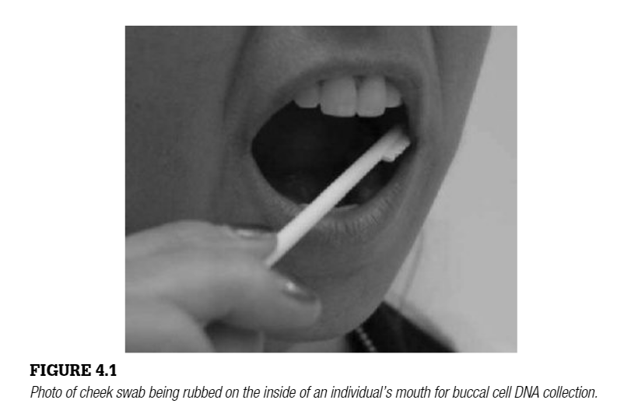

Storage of Reference DNA Samples
Both blood and buccal samples can be stored on FTA® cards, a type of chemically treated cellulose-based paper. These cards lyse cells upon contact, releasing DNA, which then binds to the card. The embedded chemicals also prevent bacterial and fungal growth, ensuring long-term stability at room temperature as long as the card remains dry.
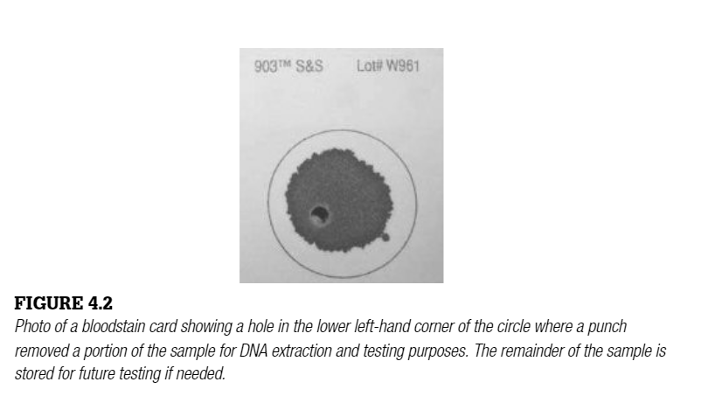
Commercial DNA Collection Systems
The Bode Buccal DNA Collector is a widely used forensic tool that simplifies direct collection. It includes a desiccant pouch to maintain dryness and a bar-coded tracking system for automated sample management. When blood samples are collected instead of buccal swabs, a few drops are typically spotted onto treated or untreated filter paper. Unlike buccal swabs, blood samples have the advantage of being visibly detectable, ensuring proper sample collection.
By utilizing non-invasive collection methods and secure storage systems, forensic laboratories ensure reliable and long-lasting reference DNA samples for crime scene investigations.

DNA SAMPLE STORAGE AND PRESERVATION
Proper storage of DNA samples is crucial to preventing degradation. The primary factors affecting DNA stability are temperature and humidity. Storing samples in cool, dry environments minimizes bacterial and fungal activity, which can rapidly break down biological material.
Short- and Long-Term Storage Methods
The appropriate storage conditions depend on the sample type:
- Buccal and crime scene swabs – Can be refrigerated for short periods, but for long-term storage, they should be dried and frozen at -20°C.
- Blood samples – Typically stored between -20°C and -70°C.
- FTA® cards – Used for buccal and blood samples, these chemically treated paper cards allow DNA to be stably stored for years at room temperature if kept dry.
For items like clothing, dry storage in acid-free paper bags is recommended, as plastic bags may trap moisture and accelerate DNA degradation. In temperate climates, DNA has been successfully recovered from materials stored at room temperature for several years.
DNA Extraction and Laboratory Storage
Once extracted, DNA should be stored at 4°C for short-term use and at -20°C to -70°C for long-term preservation. Bloodstains should be thoroughly dried before transport to prevent mold growth. If collected on cotton swabs, they must be air-dried in an open envelope before being sealed.
Inside forensic laboratories, DNA is extracted and stored in refrigerators or freezers. Extracted DNA is best preserved in dry conditions to prevent hydrolysis and enzymatic degradation. Bloodstain cards are commonly used for long-term DNA storage, as they can be vacuum-sealed with a desiccant to prevent humidity-related degradation.
Forensic Evidence Storage Facilities
Many law enforcement agencies maintain freezers in evidence lockers for rape kits and biological samples. Proper storage has enabled post-conviction DNA testing for individuals incarcerated before DNA technology became widely available.
Special Considerations for Storage and Transport
- Dried biological samples – Should be stored in paper bags or envelopes in a cool, dry environment to maintain DNA stability for months or years.
- Long-term dry storage – If samples need to be stored for more than two years, freezing below -20°C is recommended.
- Forensic samples in tropical regions – Freezing is necessary due to high humidity, which accelerates bacterial and mold growth.
- Glass slides with biological stains – Should be stored in standard slide cases or secured with sticky tape inside paper envelopes.
- Insect samples – Should not be dried, as museum beetles may destroy them. Instead, store them in 90% ethanol at room temperature for short-term use, or below -20°C for long-term DNA preservation.
Handling Unusual Evidence Types
- Cigarette butts, envelopes, fingernail clippings, dried nasal secretions – Store dry in paper bags or envelopes.
- Hair samples – Should be attached to envelopes using sticky tape or stored between filter paper layers.
- Adhesive samples (chewing gum, tape lifts, etc.) – Quick extraction with specialized lysis buffers can improve DNA recovery.
Maximizing DNA Recovery from Evidence
The success of DNA profiling depends on the amount of recoverable DNA. Cigarettes, bloodstains, and headwear have high DNA extraction success rates, even after prolonged dry storage. Metallic objects like cartridge cases and crowbars have lower success rates. When DNA concentration falls below 6 pg/μL, only 5% of samples provide meaningful profiling results, while concentrations above 100 pg/μL generally produce high-quality profiles.
Storing Extracted DNA in Buffers
Extracted DNA is commonly stored in TE buffer (10 mM Tris-HCl, 1 mM EDTA, pH 7.5) to maintain stability.
- Short-term storage – TE buffer can preserve DNA for weeks or months at 4–12°C.
- Long-term storage – Freezing below -20°C extends DNA lifespan for years.
- Aliquoting DNA before freezing prevents degradation from repeated freeze-thaw cycles.
Emergency DNA Storage in the Field
Under challenging field conditions, DNA storage can be maintained using:
- TE buffer – Autoclaved and filtered before use, allowing short-term sample preservation at room temperature.
- Ethanol storage – If immediate freezing or drying is not possible, 95% ethanol can be used for temporary DNA preservation in the field.
- Isopropyl alcohol or 70% ethanol – Can prevent mold growth on swabs if long-term storage conditions are not immediately available.
By following these protocols, forensic laboratories ensure that DNA samples remain viable for analysis, preserving their value as critical evidence in criminal investigations.

SAMPLE CHARACTERIZATION
When crime scene evidence is ﬁrst received into a laboratory, it is usually evaluated to see if any biological material is present. Some laboratories perform both preliminary tests and conﬁrmatory tests prior to sending a cutting or swab for DNA testing in an effort to develop a DNA proﬁle. A presumptive test, which really serves as a preliminary evaluation or examination, may be followed by a conﬁrmatory test to verify the results of the ﬁrst test.
Forensic serology: presumptive and conﬁrmatory tests Forensic evidence from crime scenes comes in many forms. For example, a bed sheet may be collected from the scene of a sexual assault. This sheet will have to be carefully examined in the forensic laboratory before selecting the area to sample for further testing. Prior to making the effort to extract DNA from a sample, presumptive tests are often performed to indicate whether or not biological ﬂuids such as blood or semen are present on an item of evidence (e.g., a pair of pants). Locating a blood or semen stain on a soiled
undergarment can be a trying task. Primary stains of forensic interest come from blood, semen, and saliva. Identiﬁcation of vaginal secretions, urine, and feces can also be important to an investigation. Serology is the term used to describe a broad range of laboratory tests that utilize antigen and serum antibody reactions. For example, the ABO blood group types discussed in Chapter 3 are determined using anti-A and anti-B serums and examining agglutination when mixed with a blood sample. Serology still plays an important role in modern forensic biology but has taken a backseat to DNA in many respects since presumptive tests do not have the ability to
individualize a sample like a DNA proﬁle can. Presumptive tests should be simple, inexpensive, safe, and easy to perform. They should use only a small amount of material and have no adverse effect on any downstream DNA testing that might be conducted on the evidentiary material. Besides helping to locate the appropriate material for DNA analysis, stain characterization can in some cases provide probative value to a case (e.g., semen in a victim’s mouth as evidence of an oral sexual assault).
The primary providers for presumptive forensic serology tests are Abacus Diagnostics (West Hills, CA) and Seratec (Goettingen, Germany). Their in vitro diagnostic tests, which appear very similar to home pregnancy tests, involve applying a small aliquot of a sample to a cartridge with a membrane containing speciﬁc antibodies. The presence of the appropriate molecules (e.g., hemoglobin with a blood test) on this immunochromatographic strip test will be detected as a colored line. Internal standards are run to verify that the test is working properly. Independent Forensics (Hillside, IL) has released conﬁrmatory tests for blood, saliva, urine, semen, and sperm with their Rapid Stain Identiﬁcation products (http://www.iﬁ-test.com/rsid.php). These tests are designed to not crossreact with other human body ﬂuids or body ﬂuids of other animals like some of the presumptive tests do.
Bloodstains
Blood is composed of liquid plasma and serum with solid components consisting of red blood cells (erythrocytes), white blood cells (leukocytes), and platelets (thrombocytes). Most presumptive tests for blood focus on detecting the presence of hemoglobin molecules, which are found in the red blood cells and used for transport of oxygen and carbon dioxide. A simple immu-
nochromatographic test for identiﬁcation of human blood is available from Abacus Diagnostics (West Hills, CA) as the ABAcard HemaTrace kit. This test has a hemoglobin limit of detection of 0.07 μg/mL and shows speciﬁcity for human blood along with higher primate and ferret blood.
Luminol is another presumptive test for identiﬁcation of blood that has been popularized by the TV series CSI: Crime Scene Investigation. The luminol reagent is prepared by mixing 0.1 g 3-amino-phthalhydrazide and 5.0 g sodium carbonate in 100 mL of distilled water. Before use, 0.7 g of sodium perborate is added to the solution. Large areas can be rapidly evaluated for the presence of bloodstains by spraying the luminol reagent onto the item under investigation. Objects that have been sprayed need to be located in a darkened area so that the luminescence can be more easily viewed. Luminol can be used to locate traces of blood that have been diluted up to 10 million times. The use of luminol has been shown to not inhibit DNA testing of STRs that may need to be performed on evidence recovered from a crime scene. Demonstration that presumptive tests do not interfere with subsequent DNA testing can be important when making decisions on how biological evidence is processed in a forensic laboratory.
Saliva stains
A presumptive test for amylase is used for indicating the presence of saliva, which is especially difﬁcult to see since saliva stains are nearly invisible to the naked eye. Two common methods for estimating amylase levels in forensic samples include the Phadebas test and the starch iodine radial diffusion test. Saliva stains may be found on bite marks, cigarette butts, and drink-
ing vessels. A molecular biology approach using messenger RNA proﬁling is also being taken to develop sensitive and speciﬁc tests for various body ﬂuids including saliva. Such a molecular biology test should be able to assay blood, semen, and saliva simultaneously with great speciﬁcity and sensitivity.
Semen stains
Almost two-thirds of cases pursued with traditional forensic DNA testing involve sexual assault evidence. Hundreds of millions of sperm are typically ejaculated in several milliliters of seminal ﬂuid. Semen stains can be characterized with visualization of sperm cells, acid phosphatase (AP), or prostate speciﬁc antigen (PSA or p30) tests. A microscopic examination to look for the presence of spermatozoa is performed in some laboratories on sexual assault evidence. However, aspermic or oligospermic males have either no sperm or a low sperm count in their seminal ﬂuid ejaculate. In addition, vasectomized males will not release sperm. Therefore, tests that can identify semen-speciﬁc enzymes are helpful in verifying the presence of semen in sexual assault cases.
Acid phosphatase (AP) is an enzyme secreted by the prostate gland into seminal ﬂuid and found in concentrations up to 400 times greater in semen than in other body ﬂuids. A purple color with the addition of a few drops of sodium alpha naphthylphosphate and Fast Blue B solution or the ﬂuorescence of 4-methyl umbelliferyl phosphate under a UV light indicates the presence of AP. Large areas of fabric can be screened by pressing the garment or bed sheet against an equal sized piece of moistened ﬁlter paper and then subjecting the ﬁlter paper to the presumptive tests. Alternatively, systematic searches can be done over sections of the fabric under examination to narrow the location of the semen stain with each successive test. Prostate speciﬁc antigen was discovered in the 1970s and shown to have forensic value with the identity of a protein named p30 due to its apparent 30,000 molecular weight. Protein p30 was initially thought to be unique to seminal ﬂuid although it has been reported at lower levels in breast milk and other ﬂuids. PSA varies in concentration from approximately 300 to 4200 ng/mL in semen.
Laboratory reports where presumptive tests for semen were performed may indicate that an item was found to be ‘ AP positive’ or ‘p30 positive’—in other words, semen was detected, implying some form of sexual contact on the evidentiary item.
Direct observation of sperm
Many forensic laboratories like to observe spermatozoa as part of conﬁrming the presence of semen in an evidentiary sample. A common method of doing this is to recover dried semen evidence from fabric or on human skin with a deionized water-moistened swab. A portion of the recovered cells is then placed onto a microscope slide and ﬁxed to the slide with heat. The immo-
bilized cells are stained with a ‘Christmas Tree’ stain consisting of aluminum sulfate, nuclear fast red, picric acid, and indigo carmine. The stained slide is then examined under a light microscope for sperm cells with their characteristic head and long tail. The Christmas Tree stain marks the anterior sperm heads light red or pink, the posterior heads dark red, the spermatozoa’s midpieces blue, and the tails yellowish green.
Independent Forensics (Hillside, IL) recently released the SPERM HY-LITER PLUS kit that enables detection of even a single human sperm head in the presence of an overwhelming amount of epithelial cells. Development of sample characterization tools that utilize ﬂuorescently tagged monoclonal antibodies, such as the SPERM HY-LITER kit, represents a major advancement and should enable much faster and accurate processing of sexual assault evidence.

MAIN DESTRUCTIVE INFLUENCES ON DNA
Under the influence of UV light (including sunlight) and acids, DNA contained in biological stains as well as extracted DNA breaks into pieces (degrades). Depending on the intensity of fragmentation, PCR is often possible. Humidity does not directly affect DNA but will allow mold and bacteria to destroy the sample including the DNA within days. Frequent freezing and unfreezing of stains or extracted DNA will also lead to degradation. Household use of detergents and cleaners does not necessarily destroy DNA [96].
Sperm heads on fabric may survive machine washing at 30°C–40°C if no bleach was used. However, for detection of such stains, narrowband, fixed-wavelength lighting is minimally successful at higher washing water temperatures, probably because most of the seminal fluid is dissolved during washing whereas sperm heads stick to or in between the fibers. In the beginning, acid phosphatase tests with an extended cutoff are still highly sensitive. In still ocean water, spermatozoa on cotton fabric are undetectable after 12 hours, in swimming pool water after one week, yet with no upper limit of detectability for tap or river water, even though a decreasing trend overtime occurs [97]. Semen-stained underwear DNA led to recovery of between 13 and 55 ng/µL DNA with successful STR typing in all such cases. When semen-stained underwear is washed after a month at 30°C, some semen stains can still be detected by narrowband forensic light sources or prostate specific antigen, and all stains can be successfully DNA typed [98].
CONTAMINATION
Under conditions of normal case work, contamination is only observed after careless manipulation or purposeful spraying of high (nanogram) amounts of DNA near or directly into open tubes before PCR. Secondary transfer via door handles, etc. is only a problem under extremely careless, unprofessional conditions [99–101].
Obviously, mixtures of DNA might be present in the samples themselves. Mixtures of epithelial cells with sperm can be separated by differential lysis (separation of sperm from epithelial cells) [102]. Other mixtures may show distinctively different peak heights after electrophoretic separation of the PCR products. For example, an object at a crime scene may have been touched by Person A days before a biological stain (such as blood) of Person B was deposited on the same surface. In that case, a DNA mixture might be present later. It can often be detected by the different peak heights of the STR alleles. Mouth-to-mouth-kissing is a lesser practical problem since the other person's DNA inside of the oral cavity of the other person will not show in STR systems already 1 minute after the end of the kiss [103].
Irrespective of the possible presence of mixtures, swabbing is always recommended if the items cannot be moved, are bulky, or if the stain is located on a person. Subsequent procedures like differential lysis should not be performed before DNA extraction becomes necessary. Generally, once evidence examination is completed, all biological samples should simply be stored cool and dry, and left intact as long as possible.
Care must however be taken to avoid contamination and misinterpretation of DNA that was transferred by persons not related to the (criminal) event, e.g., persons present at parties (skin), newspaper or journal readers, clothing stored on the same shelf, etc. (secondary transfer) [17,104–107]. Tertiary as well as non-transfer is also possible. Accused persons sometimes argue that their garment was used by the ‘real’ offender who did not leave traces. In sweat bands, three subsequent wearers leave their respective, full profiles on the outside (67%) and on the inside (80%) whereas profiles of only the first wearer are hardly found (one of 200 cases); a single profile of only the second wearer may be apparent in 7% of samples. It is therefore highly unlikely to wear/use a piece of clothing for even a short period of time without leaving DNA behind [69].
There are numerous guidelines concerning the handling of DNA evidence but they are sometimes limited by local regulations, education of personnel and agencies involved [108–110]. General standardization of evidence examination and procedures in the form of International Organization for Standardization (ISO) guidelines are nearly impossible due to the different composition of stains, laboratories, and evidence examination teams. A DIN/ISO (Deutsches Institut für Normung) attempt to standardize ‘recognition, recording, recovering, transport, and storage of material’ was retracte [111]. Even though laboratory gloves are not a main source for contamination, other surfaces are, including the body and clothing of the person collecting the stain. Continuous training to keep avoiding contamination in the light of today's single cell DNA approaches is necessary.
WITHDRAWAL OF SAMPLES OUT OF STORAGE
If parts of a stored biological sample need to be withdrawn for DNA extraction, forceps and scissors must be wiped with paper towels and 70% EtOH (or methylated spirits) every time they are used. In routine use, cross-contamination caused by wiped, smooth-surface forceps has not been observed. An exception is forceps with grooves. They must be autoclaved before every use because the groves quickly fill up with contaminants.
Still, especially during evidence examination and withdrawal, it is essential to take care of cross-contamination caused by contaminated distilled water, touching the swabs with used gloves, etc. Standard bacteriological procedures are an optimal guide.
Sample Retainment
It is recommended to always retain at least half of a stain in storage. One reason is that extracted DNA in liquid buffers is less durable than the original, dried stain. In addition, the defense should have a chance to reexamine the stain beginning with the original sample, not the extracted DNA. Only if DNA extraction and PCR seem to fail because of low amounts of DNA, stored samples be used up completely. This needs the consent of the prosecutor's (D.A.’s) office. Even in these cases, at least a minute amount of the original material should be stored so that future DNA technologies may be applied later on.
CONCLUSION
Collection of biological stains should be documented by photographs and drawings. Dry and cool storage will allow biological samples to be stored over years.
Extraction of DNA should be performed only if necessary for a current investigation. The original stains should never be extracted completely. Contamination in the laboratory does not occur if the sampling is performed by trained personnel. Because many surfaces and even stains like fingerprints (skin lines), corneocytes on ropes, telogenic hair, the surface of skin after showering, etc., may contain material that is suitable for DNA typing, intelligent criminalistic decisions have to be made before collecting the evidence.
Intense swabbing and the use of sexual assault kits are simple yet very important procedures that guarantee maximum yield of DNA and collection of biological material even if it is not visible at the moment of collection. Even difficult stains such as feces can be extracted and should be stored frozen whenever possible. Under extreme field conditions, 90% EtOH may be used as a collection and storage liquid.

Importance of Carefully Collecting DNA Evidence: The O.J. Simpson Case
On the night of 12 June 1994, Nicole Brown Simpson and Ronald Goldman were found brutally murdered at Ms. Simpson’s home. A few days later Ms. Simpson’s ex-husband, Orenthal James (O.J.) Simpson, was picked up by Los Angeles police ofﬁcers and became the chief suspect in the murder investigation. Due to O.J. Simpson’s successful football career and popularity, the case immediately drew the public’s attention. Over 100 pieces of biological evidence were gathered from the crime scene consisting primarily of blood droplets and
stains. DNA samples were sent to three laboratories for testing. Over the summer months of 1994, the Los Angeles Police Department (LAPD) DNA Laboratory, the California Department of Justice (CA DOJ) DNA Laboratory in Berkeley, and a private contract laboratory from Maryland named Cellmark Diagnostics performed the DNA testing using both RFLP and PCR techniques. A number of RFLP and PCR markers were examined in this high-proﬁle case. However, no STRs were typed. The so-called ‘Trial of the Century,’ People of the State of California v. Orenthal James Simpson, began in the fall of 1994. O.J. Simpson hired a legal ‘dream team, ’ which worked hard to acquit their client. O.J.’s defense team knew that the DNA evidence was the most powerful thing going against the football star and vigorously attacked the collection of the biological material from the crime scene. Through accusations of improper sample collection and handling as well as police conspiracies and laboratory contamination, the defense team managed to introduce a degree of ‘reasonable doubt. ’ After a lengthy and exhausting trial, the jury acquitted O.J. Simpson on 3 October 1995. Seven sets of bloodstains were collected by the LAPD and analyzed by the three DNA laboratories mentioned above. These sets of samples are reviewed below along with the challenges put forward by the defense team. For each sample, the statistics for the odds of a random match ranged from 1 in 40 when only PCR testing with the DQ-alpha marker was evaluated to more than 1 in 40 billion when all RFLP markers were examined. To gain a better understanding of the magnitude of the DNA testing conducted in the O.J. Simpson case, 61 items of evidence were received by CA DOJ from LAPD (Sims et al., 1995). From these evidence items, 108 samples were extracted in 22 sets and tested alongside 21 quality control samples that were coextracted and 24 extraction reagent blanks. These extraction reagent blanks were performed to verify that no contamination was introduced in the CA DOJ laboratory. From a scientiﬁc point of view, the results from the three testing laboratories agreed and more than a score of DNA markers were examined with no exclusions between the crime scene samples and Mr. Simpson. The acquittal verdict goes to show that DNA evidence is not always understood and can be quite complex to explain to the general public. Expert witnesses have the challenge of presenting the difﬁcult subjects of DNA biology, technology, and genetics, and jury members must make sense of concepts such as contamination and mixture analysis that can be fairly complex. To their credit, the defense team focused on the evidence collection and preservation as the most important issues in the trial rather than attacking the validity of DNA testing. They implicated the LAPD in planting some of O.J. Simpson’s liquid blood reference sample collected on 13 June —the day after the murders took place. Furthermore, the defense attacked the manner in which the evidence was handled in the LAPD DNA laboratory and alleged that contamination of the evidence samples by O.J.’s reference blood sample resulted from sloppy work and failure to maintain sterile conditions in the laboratory.
The contamination allegation became the focus of their arguments because much of the evidence had been handled, opened, and supposedly contaminated in the LAPD lab before it was packed up and sent to other laboratories for further testing. Thus, according to the defense, no matter how carefully the samples were handled by the California Department of Justice DNA Laboratory or Cellmark Diagnostics, their testing results would not reﬂect the actual evidence from the crime scene. Since the samples were supposedly tainted by the LAPD laboratory, the defense argued that the evidence should not be considered conclusive. However, the sheer number of DNA samples that typed to O.J. makes it hard to believe that some random laboratory error made it possible to obtain such overwhelmingly incriminating results. Since the conclusion of the O.J. Simpson trial in 1995, forensic DNA laboratories have improved their vigilance in conducting DNA evidence collection and performing the testing in a manner that is above reproach. Because PCR is an extremely sensitive technology, laboratories practicing the technique need to take extraordinary measures to prevent contamination in the laboratory. Hence, the value of laboratory accreditation and routine proﬁciency tests to verify that a laboratory is conducting its investigations in a proper and professional manner is clear.
The issuance of the DNA Advisory Board (DAB) Quality Assurance Standards has helped raise the professional status of forensic DNA testing. It is noteworthy that in a systematic analysis of circumstances normally encountered during casework, no PCR contamination was ever noted according to a 1999 study (Scherczinger et al., 1999). Signiﬁcant contamination occurred only with gross deviations from basic preventive protocols, such as those outlined in the DAB Standards, and could not be generated by simple acts of carelessness. Arguably the most important outcome of the O.J. Simpson trial was the renewed emphasis placed on DNA evidence collection.

